KIGALI INDEPENDENT UNIVERSITY
ULK
P.O Box 2280 Kigali, Rwanda



Development of an AI-Powered Voice Assistant for Trauma Support Using Machine Learning and Natural Language Processing.
NAYA

By

Furaha KASOKI LUVAGHO

Dissertation Submitted in Partial Fulfillment of the requirements for the award of Master’s
Degree in MASTERS OF SCIENCE IN INTERNET SYSTEM

April 2026

Table of contents
ii. Declaration 2
iii. Approval by Supervisor(s) 3
iv. Copyright Reserved by the author. 4
v. Dedication 5
vi. Acknowledgement 6
vii. List of Tables 7
viii. List of illustrations or Figures 8
ix. Abbreviations and Acronyms 9
x. Abstract 10
I. GENERAL INTRODUCTION 11
I.1. Background of the Study 11
I.2. Statement of the Problem 12
I.3. Objectives of the Study 13
I.3.1. General Objective 13
I.3.2. Specific Objectives 13
I.4. Scope of the Study 14
I.5. Significance of the Study 14
II. LITERATURE REVIEW 16
II.0 Introduction 16
II.1 Conceptual review 16
1. Artificial Intelligence (AI) 16
2. Machine Learning (ML) 16
3. Natural Language Processing (NLP) 17
4. Voice Assistants 18
5. Trauma Informed Care 19
6. Emotional AI (Affective Computing) 19
II.2 Theoretical review 20
1. Congitive Behavioral Theory CBT 20
2. Affective Computing Theory 21
II.3 Empirical Review 22
II.4 Conceptual Framework Diagram 22

ii. Declaration

I hereby declare that this dissertation entitled NAYA is my original work and has not been submitted, in whole or in part, for the award of any degree in any other university or institution of higher learning.
All sources of information used in this study have been duly acknowledged and referenced in accordance with academic standards.

Student’s Name: Fuaraha Kasoki Luvagho
Signature: _____
Date: April 2026

iii. Approval by Supervisor(s)

The approved supervisors have to sign the declaration page following the statement that: “This dissertation titled….. has been done under my (our)supervision and submitted for examination with my (our) approval Supervisor(s).Name(s) and signature Date…..

Supervisor’s Name: Prof Martins
Signature: _
Date: 2026

iv. Copyright Reserved by the author.

The text is Copyright © year of the work. Name of the author.
All rights reserved. No part of this Dissertation may be reproduced or transmitted without prior written permission of the author.

Dedication

I dedicate this work to all individuals around the world who are going through trauma and various life difficulties. May this effort, in its own way, contribute to comfort, understanding, and support for those facing unseen struggles.
I also dedicate this work to the memory of those who lost their battles before us. Their experiences and struggles will never be forgotten, and they remain a source of reflection and purpose in the pursuit of solutions that bring hope and healing.

Acknowledgement

I would like to express my sincere gratitude to God for granting me the strength, wisdom, and perseverance to successfully complete this work.
My heartfelt appreciation goes to the Founder and President of ULK for establishing an academic environment that promotes excellence and research.
I am deeply grateful to my supervisor for this guidance, valuable insights, and continuous support throughout the development of this dissertation.
I also extend my appreciation to all respondents who participated in this study, as well as to the academic and administrative staff of ULK for their assistance and cooperation.
Special thanks go to my parents, MARCEL KATAMWEYA and DESANGE KIKOLERY, for their unwavering support, encouragement, and sacrifices throughout my academic journey.
Finally, I would like to acknowledge my colleagues and friends for their support and motivation during the course of this research.

List of Tables

Lists tables in the dissertation with the corresponding pages. Each table is numbered chronologically per chapter from Table 1 to Table 3.1(this is the first table in Chapter 3). The table titles are placed on the top of the table and bold. In the APA style, the tables do not have vertical lines

List of illustrations or Figures

Each figure is numbered chronologically per chapter from figure 1 as Table 3.2(this is the second figure in chapter 3)
The figure titles are placed at the bottom of each figure. The figure title should be accompanied by a legend to announce what each item in the figure stands for and that the figure explains itself.

Abbreviations and Acronyms

AI : Artificial Intelligence

ML : Lachine Learning

NLP : Natural Language Processing

CBT : Cognitive Behavioral Theory

ACT : Affective Computing Theory

RL : Reinforcement learning

Abstract

The abstract is a comprehensive summary of the whole study. It should be no longer than one page containing between 100 and 500 words. The abstract/summary highlights the type of study, the purpose/aim, objectives, methodology, major findings, and conclusion. Avoid structured abstracts. Abstracts should be formatted as a single paragraph in a block format and with no paragraph indentations.

GENERAL INTRODUCTION

In recent years, the rapid advancement of Artificial Intelligence (AI) technologies has transformed the way individuals interact with digital systems, particularly through voice based interfaces. Voice assistants have become increasingly prevalent in everyday life, enabling users to access information and services through natural language communication. These systems are powered by technologies such as speech recognition and Natural Language Processing (NLP), which allow machines to interpret and respond to human speech (Jurafsky & Martin, 2023). As AI continues to evolve, its applications have extended beyond general purpose assistance into more sensitive domains such as healthcare and mental health support.
At the same time, the global demand for mental health services has significantly increased due to rising cases of psychological distress, trauma, anxiety, and depression. According to the World Health Organization, mental health conditions affect a substantial proportion of the global population, yet access to professional care remains limited, particularly in low resource settings (World Health Organization [WHO], 2022). Barriers such as stigma, high treatment costs, and shortage of qualified professionals prevent many individuals from seeking help (Patel, V. et al., 2018).
In response to these challenges, AI driven conversational systems have emerged as potential tools for providing accessible and scalable mental health support. Studies have shown that conversational agents can deliver basic psychological interventions and emotional support, particularly for individuals who may feel uncomfortable discussing their problems with others (Fitzpatrick et al., 2017). These systems offer advantages such as anonymity, availability, and consistency, which make them suitable for initial support and guidance.
Furthermore, voice based interaction provides a more natural and intuitive way for users to communicate their emotions compared to text based systems. During moments of emotional distress, individuals may find it easier to speak rather than type, making voice enabled AI systems particularly relevant for trauma support applications (Miner et al., 2019). This creates an opportunity to design systems that are not only intelligent but also empathetic and responsive to human emotional needs.
In this context, this study developed Naya, an AI powered voice assistant designed to provide trauma informed emotional support. The system was activated using the wake phrase “Hey Naya” and integrated speech recognition, natural language understanding, and emotionally adaptive response generation. Unlike traditional chatbots, Naya was designed to simulate supportive human like interaction while incorporating ethical safeguards to ensure user safety. The system aimed to bridge the gap between technology and psychological support by providing real time, accessible, and private assistance to individuals who may not have access to traditional therapy or may be reluctant to seek it.

I.1. Background of the Study
Psychological trauma has become a major global public health concern, affecting individuals across all regions of the world. Exposure to traumatic events such as violence, accidents, abuse, and natural disasters has been linked to the development of mental health conditions including Post Traumatic Stress Disorder (PTSD), anxiety, and depression. According to the World Health Organization, mental health disorders affect nearly one in eight people worldwide, with trauma related conditions contributing significantly to this burden (World Health Organization [WHO], 2022). Similarly, the American Psychiatric Association highlights that trauma can have long term psychological and emotional consequences if not properly addressed (American Psychiatric Association, 2023).
Despite the growing need for mental health support, access to professional care remains limited globally. Factors such as social stigma, high costs of treatment, shortage of mental health professionals, and lack of awareness prevent many individuals from seeking help (Patel, V. et al., 2018). In low and middle income countries, including many African nations, the treatment gap for mental health disorders is estimated to exceed 75%, leaving a large proportion of affected individuals without adequate care (WHO, 2022).
In the African context, mental health services face additional challenges, including limited infrastructure, cultural perceptions surrounding mental illness, and insufficient integration of mental health into primary healthcare systems (Sankoh et al., 2018). In countries such as Rwanda, the history of traumatic events has increased the prevalence of trauma related conditions, while access to psychological services remains constrained (Ng et al., 2015). These challenges highlight the urgent need for innovative and accessible solutions to support individuals experiencing emotional distress.
In recent years, advancements in Artificial Intelligence (AI), particularly in Machine Learning (ML) and Natural Language Processing (NLP), have enabled the development of intelligent conversational systems capable of understanding and responding to human language. Technologies such as AI chatbots and virtual assistants have been increasingly applied in mental health care to provide immediate, scalable, and cost effective support (Fitzpatrick et al., 2017). These systems offer anonymity and 24/7 availability, making them particularly suitable for individuals who may be reluctant to seek traditional therapy.
Furthermore, the widespread adoption of smartphones and web technologies has created new opportunities for delivering digital mental health interventions. Voice based interaction, in particular, provides a more natural and accessible way for users to communicate their emotions, especially during moments of distress when typing may be difficult or overwhelming (Jurafsky & Martin, 2023).
In response to these challenges, this study developed Naya, an AI powered voice assistant designed to provide trauma informed emotional support. The system was activated using the wake phrase “Hey Naya” and integrated speech recognition, natural language understanding, and emotionally adaptive response generation to simulate supportive human like interaction. Unlike traditional chatbots, Naya was designed with trauma informed principles to ensure safe, empathetic, and non judgmental communication. This innovation aimed to bridge the gap between technology and psychological support, particularly for individuals who are unable or unwilling to seek traditional therapy.

I.2. Statement of the Problem
Despite the increasing prevalence of trauma related mental health conditions, access to immediate and effective support remained a major challenge. Many individuals avoided seeking professional help due to stigma, financial limitations, or lack of available services. As a result, a significant number of people continued to suffer in silence without receiving timely intervention. Although AI based mental health applications have been developed, most existing systems lacked trauma specific design, emotional sensitivity, and voice based interaction capabilities. In addition, many systems were not equipped with appropriate safety mechanisms to handle users in critical emotional states, which could lead to ineffective or potentially harmful responses. Furthermore, there was limited research on AI powered voice assistants specifically designed for trauma support, particularly in mobile first environments. This created a gap in the development of systems that are both technically advanced and psychologically safe.

I.3. Objectives of the Study

I.3.1. General Objective
To design and develop an AI powered voice assistant for trauma support using Machine Learning and Natural Language Processing.

I.3.2. Specific Objectives

The study was guided by the following specific objectives and corresponding research questions :

- To analyze trauma informed care principles relevant to AI systems :
This objective aimed to examine the key principles of trauma informed care and their relevance in the design of AI based systems such as Naya.

Research Question 1:
How can trauma informed care principles be integrated into AI-powered voice assistants?

- To develop a voice based AI assistant activated by the phrase “Hey Naya.” :
This objective focused on designing and implementing a voice activated system that allows users to interact naturally with the assistant.

Research Question 2:
How can a wake-word activated voice assistant be designed to provide accessible and user-friendly interaction?

- To implement speech recognition and natural language understanding for emotional interaction :
This objective aimed to integrate technologies that enable the system to interpret user speech and understand emotional context.
Research Question 3:
To what extent can speech recognition and natural language processing accurately interpret trauma related user input?

- To design an empathetic response system for trauma related conversations.
This objective focused on developing a system capable of generating supportive and emotionally appropriate responses.

Research Question 4:
How effectively can an AI system generate empathetic responses in trauma related interactions?

- To evaluate the usability and perceived effectiveness of the system.
This objective aimed to assess user experience and the overall usefulness of the system.

Research Question 5:
How usable and effective is the AI powered voice assistant in providing trauma support to users?

I.4. Scope of the Study
This study focuses on the design and development of a voice based Artificial Intelligence assistant aimed at providing trauma informed emotional support. The system is implemented using Flutter for the mobile application and React with Tailwind CSS for the web platform, ensuring accessibility across both mobile and web environments.
The study covers key technological components, including speech recognition, Natural Language Processing (NLP), and automated response generation, which enable the system to interact with users through natural and meaningful voice based communication. Additionally, the system integrates a wake word activation mechanism (“Hey Naya”) to facilitate hands free and intuitive user interaction.
The scope of the study is not restricted to a specific geographical region, as the system is designed for general use across diverse user groups, particularly individuals seeking initial emotional support. The study is conducted within the timeframe allocated for the Master’s program.
Furthermore, the system is designed to provide initial emotional support and guidance to users experiencing trauma or psychological distress. However, the system does not perform clinical diagnosis, provide medical treatment, or replace professional mental health services. Instead, it complements existing mental health support systems by offering accessible, immediate, and user friendly assistance.

I.5. Significance of the Study
This study contributes to the fields of Artificial Intelligence, Natural Language Processing, and digital mental health through the design and development of a trauma informed voice assistant. It provides a practical approach to improving access to emotional support services by leveraging modern technological solutions.
The system offers significant benefits to users by delivering anonymous, immediate, and easily accessible support, which is particularly important for individuals who may face barriers in seeking traditional mental health services. By enabling users to express themselves freely without fear of stigma, the system promotes early emotional intervention and support.
Furthermore, this study contributes to researchers and developers by demonstrating how artificial intelligence can be ethically and effectively applied in emotionally sensitive contexts. It highlights the importance of integrating empathy, safety, and user centered design into AI systems intended for mental health support.
In addition, the study supports the integration of AI technologies into healthcare systems, especially in low resource environments where access to professional mental health services is limited. By providing an alternative support tool, the system has the potential to complement existing healthcare services and enhance overall well being in underserved communities.

LITERATURE REVIEW

II.0 Introduction

This chapter reviewed existing literature related to Artificial Intelligence, Natural Language Processing, voice assistants, and trauma-informed care. It examined key concepts, theoretical foundations, and previous studies relevant to the development of Naya. The chapter also identified research gaps that justified the need for this study and presented the conceptual framework guiding the research

II.1 Conceptual review

Artificial Intelligence (AI)
Artificial Intelligence Is the ability of a digital computer or computer controlled robot to perform tasks commonly associated with intelligent beings. The term is frequently applied to the project of developing systems endowed with the intellectuel processes characteristic of humans, such as the ability to reason, discover meaning, generalize, or learn from past experience. Since their development in the 1940s, digital computers have been programmed to carry out very complex tasks such as discovering proofs for mathematical theorems or playing. With great proficiency. Despite continuing advances in computer processing speed and memory capacity, there are as yet no programs that can match full human flexibility over wider domains or in tasks requiring much everyday knowledge. On the other hand, some programs have attained the performance levels of human experts and professionals in executing certain specific tasks, so that artificial intelligence in this limited sense is found in applications as diverse as medical diagnosis, computer search engines, voice or handwriting recognition, and chatbots (B.J. Copeland, Apr.2,2026. History).
In the context of this study, AI was used to enable Naya to understand user input and generate appropriate responses.

Machine Learning (ML)

Machine Learning is a subset of artificial intelligence that focuses on creating algorithmes capable of learning patterns from data and making predictions or decisions without explicit programming for each task. By training on historical datasets these models generalize to unseen data, enabling automation and intelligent decision making across industries.
At its core Ml works by feeding data into algorithms, adjusting internal parameters to minimize prediction errors and producing a trained model that can classify, predict or detect patterns in new inputs.
This process can be applied to structured data (financial records or unstructured data, ….
eg : images, textes, audio, ….). (IBM Journal (accessed through MIT), 3 July 1959).
Machine Learning allows systems to learn from data and improve performance without being explicitly programmed. In Naya, ML techniques were used to analyze patterns in language and detect emotional cues.
All machine learning methods can be categorized as one of three distinct learning paradigms : supervised learning, unsupervised learning or reinforcement learning, based on the nature of their training objectives and (often but not always) by the type of training data they entail.

- Supervised learning : trains a model to predict the “correct” output for a given input. It applies to tasks that require some degree of accuracy relative to some external "ground truth," such as classification or regression.
- Unsupervised learning : trains a model to discern intrinsic patterns, dependencies and correlations in data. Unlike in supervised learning, unsupervised learning tasks don’t involve any external ground truth against which its outputs should be compared.
- Reinforcement learning (RL) : trains a model to evaluate its environment and take an action that will garner the greatest reward. RL scenarios don’t entail the existence of a singular ground truth, but they do entail the existence of ‘good’ and ‘bad’ (or neutral) actions.

Natural Language Processing (NLP)

NLP combines computer science, linguistics, and machine learning to enable computers to read,understand, and respond to human language in way that is both meaningful and contextually appropriate. Its goal is to bridge the gap between human communication and computer comprehension, making it possible for machines to process natural language data such as txt, speech and social media content. (Kuei-Hu Chang, Applied Sciences, 2023, Volume 13, Issue 20, Article 11395).

Key Components of NLP :

- Tokenization : Breaking text into smaller units like words or sentences for processing.
- Part-of-Speech Tagging : Identifying grammatical roles such as nouns, verbs and adjectives in text.
- Named Entity Recognition (NER) : Detecting and classifying entities like names, locations, dates and organizations.
- Parsing : Analyzing the syntactic structure of sentences to understand relationships between words.
- Sentiment Analysis : Determining the sentiment or opinion expressed in text, such as positive, negative or neutral.
- Machine Translation : Automatically translating text from one language to another.
- Text Summarization : Producing concise summaries of longer documents while retaining key information.

Applications of NLP :

- Virtual Assistants and Chatbots : Tools like Siri, Alexa, and customer service bots rely on NLP to understand user queries.
- Search Engines : Improve relevance by interpreting user intent beyond keyword
  - matching.
- Social Media Analysis : Monitor public opinion, detect trends, or analyze sentiments from posts and comments.
- Translation Services : Google Translate, DeepL, and similar applications use NLP to
  - convert languages accurately.
- Speech Recognition Systems : voice controlled applications and transcription services transform spoken language into text.
- Information Retrieval and Question Answering : Systems can answer user questions or extract necessary information from documents.

How NLP Works

NLP often uses machine learning models and artificial neural networks, including modern deep learning and transforme-based architectures like BERT, GPT or T5. These models are trained on large datasets to recognize patterns.context and semantics in language. Preprocessing tasks like cleaning txt, stemming, and lemmatization improve model accuracy.
NLP also relies on statistical, linguistic and rules based methods to extract meaning and predict language patterns.
NLP played a central role in Naya by allowing the system to interpret user speech and generate meaningful responses.

Voice Assistants
A voice assistant is simply a device or an application that is used to perform different tasks by using voice commands. Some popular examples of these assistants include Apple’s Siri and Alexa. (Wise Toast business lifestyle magazine, Sunday, 5 April by Fawad Malik).
These types of programs are very smart and understand human language perfectly. People can ask questions, have a conversation or simply ask the program to do a certain task. Voice assistants have been in the market for more than a decade now.
Naya functioned as a voice assistant activated by the phrase “Hey Naya,” enabling hands-free and natural interaction.

Trauma Informed Care
Trauma informed care is an approach in healthcare and psychological support that acknowledges the widespread impact of trauma and integrates this understanding into all aspects of service delivery. According to the Substance Abuse and Mental Health Services Administration (SAMHSA), trauma informed care is guided by key principles such as safety, trustworthiness, peer support, collaboration, empowerment, and cultural sensitivity.
This approach emphasizes creating environments where individuals feel physically and emotionally safe, while avoiding practices that may inadvertently re-traumatize them. It also promotes active listening, empathy, and respect for the user’s experiences.
In the context of this study, trauma informed care served as a foundational framework for the design of Naya. The system was developed to ensure that all interactions are non-judgmental, supportive, and user-centered. For instance, Naya avoids harsh or directive language and instead uses calming, validating responses that acknowledge the user’s emotional state.(Substance Abuse and Mental Health Services Administration (SAMHSA). (2024). SAMHSA’s Concept of Trauma and Guidance for a Trauma-Informed Approach.)

Emotional AI (Affective Computing)
Emotional AI, also known as affective computing, is a field within artificial intelligence that focuses on the recognition, interpretation, and simulation of human emotions through computational systems. The term was popularized by Rosalind Picard, who defined it as systems that can detect and respond to emotional states in a way that enhances human computer interaction.
Emotional AI systems typically rely on data inputs such as speech patterns, facial expressions, text sentiment, and physiological signals to infer emotional states. Techniques such as natural language processing (NLP), machine learning, and sentiment analysis are commonly used to classify emotions like happiness, sadness, anxiety, or stress.
In this study, emotional AI techniques were integrated into Naya to enable the system to recognize user emotional states and adapt its responses accordingly.
For example, when a user expresses distress or anxiety, Naya responds with supportive and empathetic language rather than neutral or generic replies. This dynamic response capability enhances user engagement and aligns with the principles of trauma-informed care by providing personalized emotional support.
Furthermore, the use of emotional AI contributes to creating a more human like and responsive interaction, which is essential for applications in mental health and trauma support. (Calvo, R. A., & D’Mello, S. (2010). Affect Detection: An Interdisciplinary Review of Models, Methods, and Their Applications.).

II.2 Theoretical review

Congitive Behavioral Theory CBT
Cognitive Behavioral Theory (CBT) is a psychological framework that explains the dynamic relationship between cognitions (thoughts), emotions, and behaviors. Developed by Aaron Beck, CBT posits that maladaptive or distorted thinking patterns can lead to negative emotional responses and unhelpful behaviors.
The theory emphasizes that individuals can improve their emotional well being by identifying, challenging, and restructuring negative thought patterns, thereby influencing their emotional and behavioral responses. CBT is widely used in the treatment of conditions such as anxiety, depression, and trauma related disorders.
In this study, CBT informed the design of Naya by guiding the generation of supportive, constructive, and reframing responses.
For example, when users express distressing thoughts, the system responds with language that encourages positive reinterpretation, emotional validation, and gentle cognitive restructuring. This approach helps users move from harmful thought patterns toward more balanced and adaptive perspectives. (Beck, A. T. (1976). Cognitive Therapy and the Emotional Disorders.) (American Psychological Association (CBT resources and guidelines).

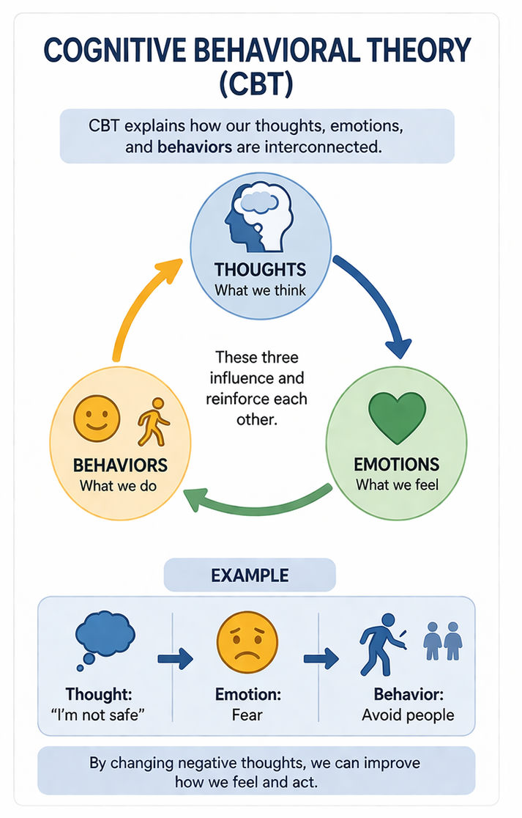

Affective Computing Theory
Affective Computing Theory refers to the study and development of computational systems capable of recognizing, interpreting, processing, and responding to human emotions. This concept was pioneered by Rosalind Picard, who defined it as enabling machines to interact with humans in emotionally intelligent ways.
The theory integrates techniques from artificial intelligence, machine learning, and natural language processing (NLP) to analyze emotional cues from various inputs such as text, speech, facial expressions, and physiological signals. These systems aim to enhance human computer interaction by making it more adaptive, personalized, and empathetic.
In the context of this study, Affective Computing Theory guided the development of Naya’s ability to detect user emotional states and generate context aware responses. For instance, sentiment analysis and emotion classification techniques allow the system to identify feelings such as anxiety or sadness and respond with appropriate supportive language. This enhances the system’s effectiveness in providing emotionally sensitive assistance, particularly in trauma related contexts. (Picard, R. W. (1997). Affective Computing. MIT Press.) .

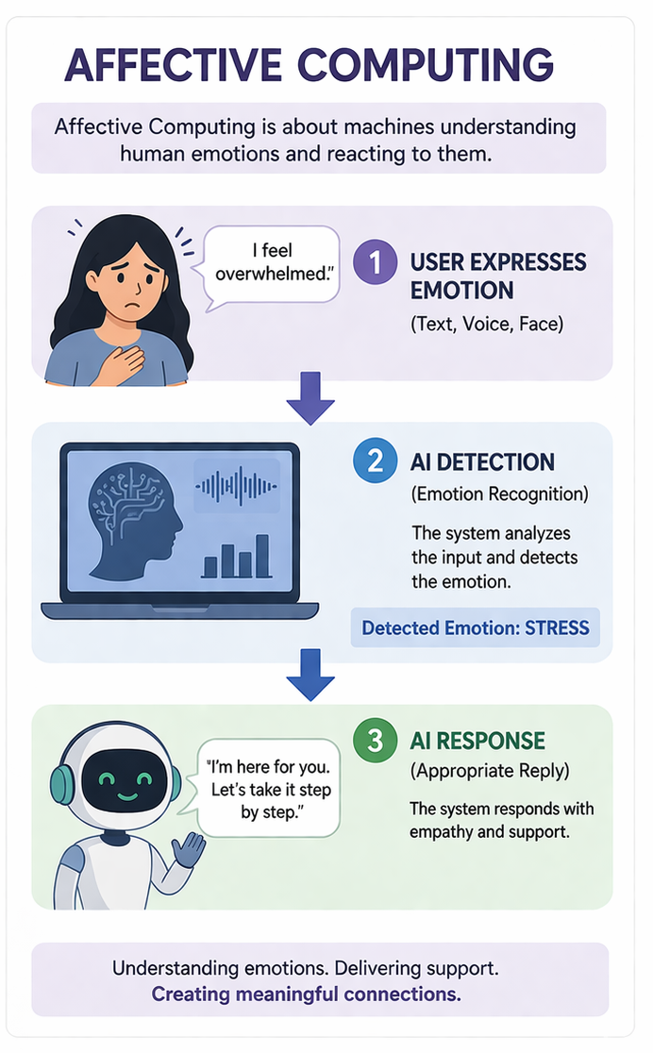

II.3 Empirical Review
Previous studies have explored the use of AI in mental health support, particularly through chatbots and conversational agents. Research has shown that such systems can help reduce stress and provide basic emotional support.
However, most existing systems are text based and lack voice interaction capabilities. Additionally, many do not incorporate trauma informed principles or advanced emotional understanding.
This study addressed these gaps by developing a voice based AI assistant with trauma sensitive design and emotional awareness.

II.4 Conceptual Framework Diagram

